**EMAIL DETAILS FOR JOB APPLICATION**

**Username:** [abicmprecruitmenthub1@gmail.com](mailto:abicmprecruitmenthub1@gmail.com)  
**Password:** Abicmp0156

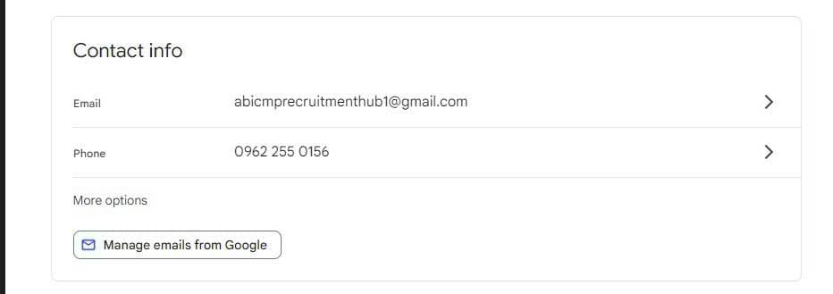

**Username:** [abicmprecruitmenthub2@gmail.com](mailto:abicmprecruitmenthub2@gmail.com)  
**Password:** Abicmp0154

